Supporting Service Children through the use of Pupil Premium at Ranvilles Junior School
Background/Context
Approximately 30% of the pupils at Ranvilles Junior School come from a Service family. The vast majority of our Service parents serve in the Royal Navy, although we do have small representations from the Army, RAF and occasionally overseas Armed Forces families.
Service pupil premium funding is intended to assist the school in providing the additional support that service children may need, be this academic, emotional or pastoral. We are committed to ensuring that these needs are being met and have developed a specific project called HMS Ranvilles within school to help mitigate any negative impact on service children of family mobility or parental deployment. In addition to meeting these needs, we also aim to celebrate and recognise the immense feelings of pride that children feel about their parents through this project. HMS Ranvilles includes children who are in receipt of Service Pupil Premium.
The Adventures of Nelson the Sailor Bear Project
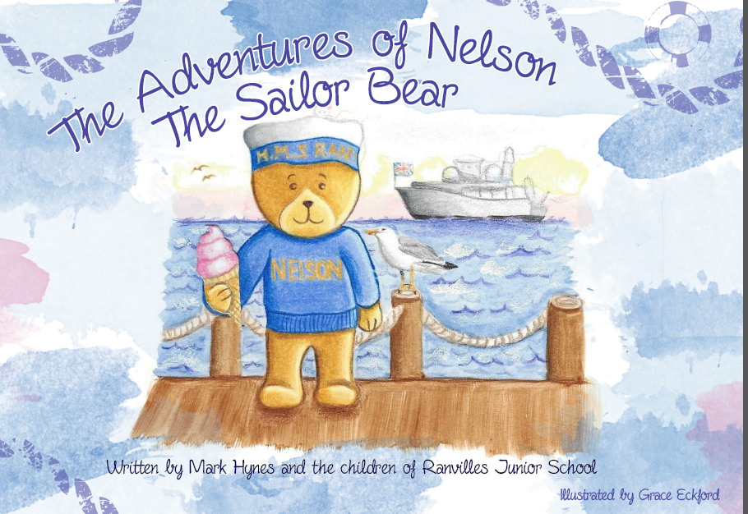
Picture 1- Front cover
As part of a wide range of activities/experiences available for HMS Ranvilles children to participate in, we have a teddy bear who the children have named Nelson. This bear’s purpose was to go on deployment with serving parents and report back to them describing what life at sea was like. We were fortunate that a parent agreed to take the bear and send back emails and postcards to the children so that they could share in the experience and learn about the work of the Royal Navy.
The quality of the emails and postcards we received were exceptional and we did not want to miss out on the opportunity to develop the project further so we applied to the MOD Education Fund for a grant to finance the production of a hard-back, colour book. We wanted the book to be given to all the children in the school (service and non-service) with the aim of providing service children with a record of the adventures which they could read and refer to whenever their parent was away and also to grow awareness of service life within the school. We also wanted to use the book as a vehicle for supporting service children emotionally and planned to include a ‘Top Tips’ section for when parents are away. The cost of the project was calculated and we sourced a local printer and illustrator who gave us a quotes which we used to formulate a budget for the application. A military sponsor was also required as part of the application process. We were supported by a parent who is a serving member of the Armed Forces. We were delighted to be awarded a grant of £3000 to support the development of this project.

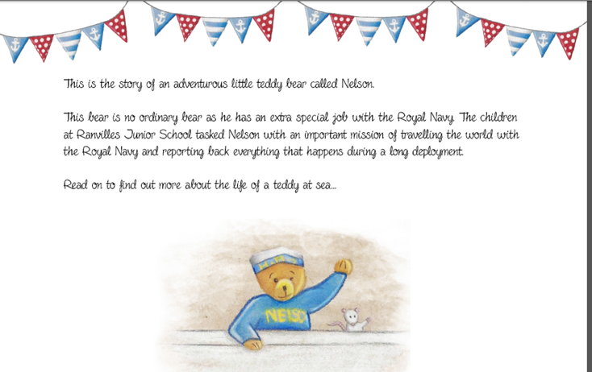
Picture 2- Sample page

We were keen that all the service children in the school had an input into the writing and production of the book so we ran workshops for them to make their contributions. To gain inspiration and a deeper understanding about ‘life on board’ we visited the National Museum of the Royal Navy in Portsmouth Historic Dockyard. This helped the children to explore the different aspects of service life through a range of first hand experiences including role play, investigating the Hear My Story exhibition and learning about the history of the Royal Navy.
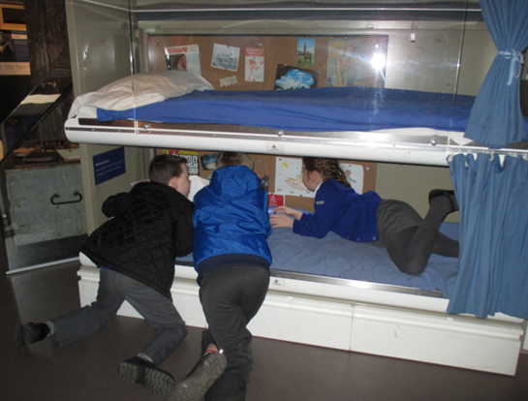
Picture 3- Investigating cabins on a modern warship
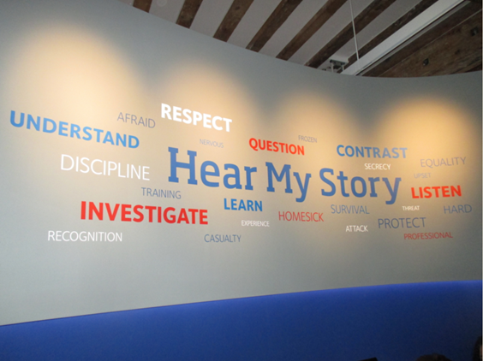
Picture 4- Exploring the Hear My Story Exhibition
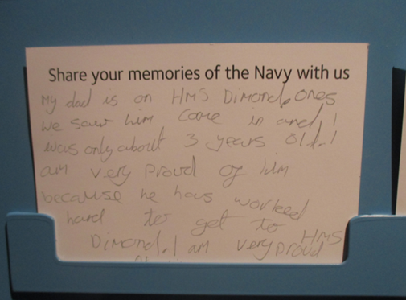
Picture 5- Sharing personal memories at The National Museum of the Royal Navy
Back at school, the small workshops focussed on the children writing the introduction to the book and sharing ‘Top Tips’ of how to cope with feelings and emotions when a parent is deployed. The idea was that they could look at these tips and use them should they need to. These workshops also provided a talking point for children to share their own experiences of mobility and deployment. We found that through the workshops, children got to know each other better and were much more aware of other service children within school which then helped to develop a support network in school for them to tap into.
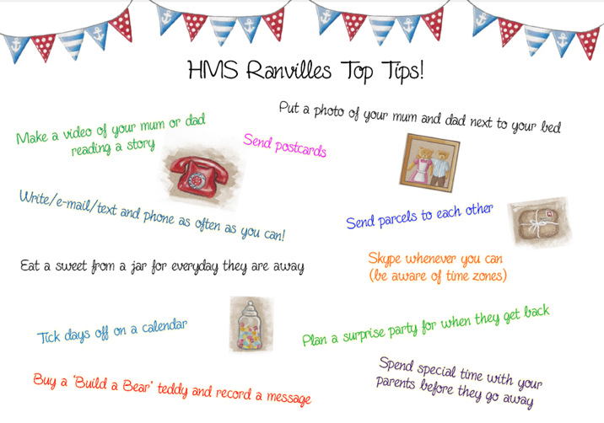
Picture 6- ‘Top Tips’ page
To celebrate the project and to launch the book across the school, we held a special HMS Ranvilles day based on ‘The Adventures of Nelson the Sailor Bear’. This was organised into a morning and afternoon session. In the morning session, the children were involved in a range of activities focussed on different aspects of the book, for example Year 3 tracked Nelson’s journey using atlases and wrote postcards to him whilst Year 5 and 6 investigated responses to disaster relief and created a PowerPoint to present to their class. The afternoon session was built upon themes of teamwork, leadership, perseverance and collaboration. We invited parents who were serving members of the Armed Forces to support us with outdoor activities, which included ‘Cross the Swamp’, ‘Bench Challenge’, ‘Hula Hoop Challenge’ and ‘Drill’. Children rotated round all the activities with certificates being awarded for each of the themes mentioned. At the end of the afternoon, all children were presented with their own personal book to take home and keep.
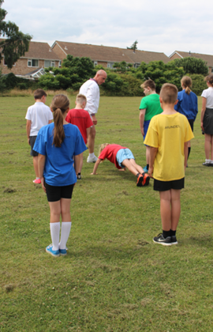
Picture 7- Drill Challenge- Perseverance
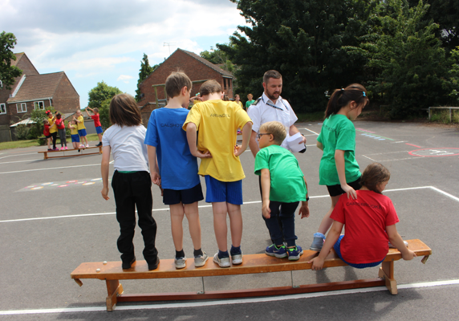
Picture 8- Bench Challenge- Leadership
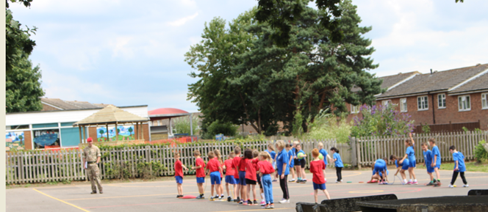
Picture 9- Cross the Swamp Challenge- Teamwork
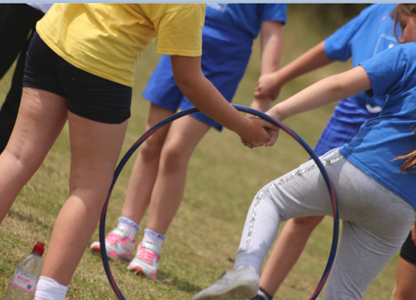
Picture 10- Hula Hoop Challenge- Collaboration
In summary, we believe that this project has been very successful in supporting service children with their feelings and emotions and also has developed awareness of service life within school.
Please visit the Ranvilles Junior School website for more information on how we use Service Pupil Premium or contact Gayle Wallace using the email address below.
g.wallace@ranvilles-jun.hants.sch.uk

